**CSE 5322 Software Design Pattern**

**Homework 4**

**State Machine**

The mower always starts and moves eastwards when first switched on.

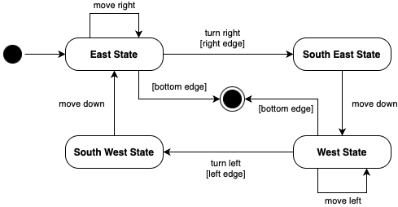

**UML Class Diagram**

Below is the class diagram for the state machine by applying the state pattern.

The client side has not been designed since the task is to only convert state machine into UML class diagram.

**Design**

**Expanded Use Case**

|  |  |
| --- | --- |
| UC: Mow lawn | |
| Pre-condition: There is land for mower to mow. | |
| Actor: User | System: Lawn Mower |
|  | 1. GUI displays the lawn to user. |
| 1. User clicks on the start button | 1. (*) Lawn mower starts the mower and sees the grass cut after timer ends. |
| 1. User sees the grass cut by the mower. |  |
| Post-condition: Lawn is mowed. | |

**Design Sequence Diagram**

**Design Class Diagram**

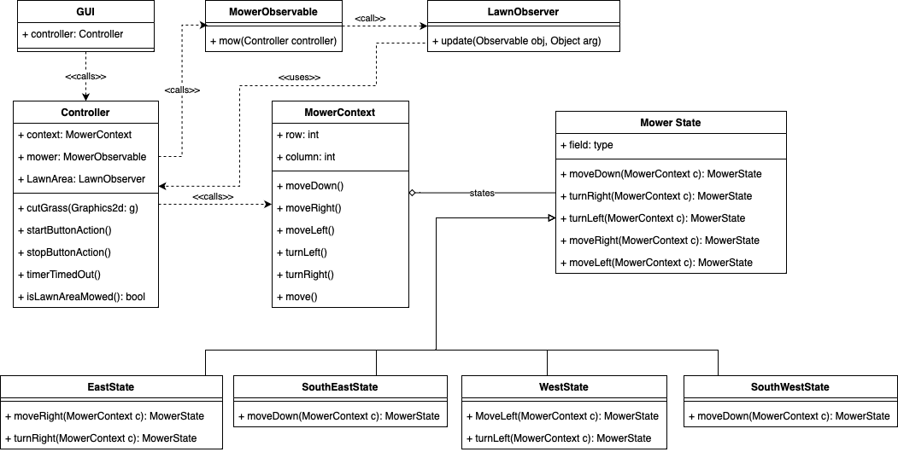

**Implementation**

1. A jar file called Arya_Shubham_CSE5322_S23_HW4_impl.jar is submitted which can be clicked to run the software.
2. You can also run the software by locating the folder Arya_Shubham_CSE5322_S23_HW4_impl on your terminal,

javac GUI.java

java GUI

1. Screenshot showing working of lawn mower below:

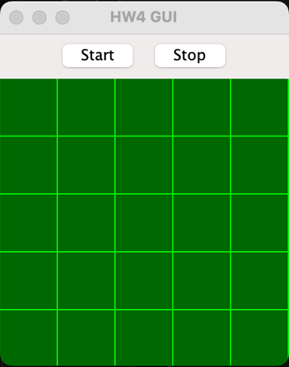

Initial State for Lawn Mower. Start button starts the lawn mower.

Stop button stops lawn mower. Lawn mower finishes mowing the lawn.